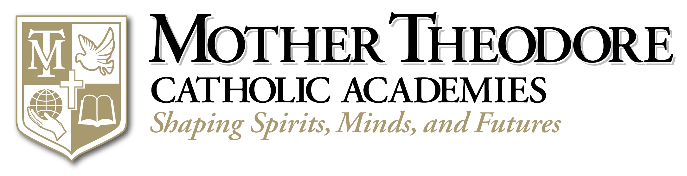
“We carry out the mission of educating center-city school children not because they are Catholic, but because we are Catholic.” —Archbishop Daniel M. Buechlein, O.S.B.

The Archdiocese of Indianapolis has long realized the vital importance of the ministry of Catholic education in the center-city. In 2004, Archbishop Buechlein formed a consortium of center-city schools, that have recently been re-named, the Mother Theodore Catholic Academies (MTCA), that were not economically viable to remain operating on their own. This consortium approach assists the schools in operating more efficiently by consolidating and coordinating such areas as finance, maintenance, school improvement, Catholic identity and marketing. “It’s not just [a sharing of] financial resources but human resources,” said Tony Watt, MTCA Chairman of the Board. One of the goals of the consortium is to extract the principal from non-academic tasks. There is now a team of three principals for the six schools with campus directors at each site. This change in governance has brought about great efficiencies, good stewardship of resources and the empowerment of educators to do what they do best.
The Mother Theodore Catholic Academies, named for Indiana’s first saint, Saint Mother Theodore Guerin (St. Theodora) are Holy Angels Catholic School, Holy Cross Central School, Central Catholic School, St. Andrew & St. Rita Catholic Academy, St. Anthony Catholic School and St. Philip Neri School, all in Indianapolis. Saint Theodora was known for her dedication and selflessness to administer to the needs of others. Mother Theodore Catholic Academies are open to children of all religions, ethnicities, and economic backgrounds. Our schools remain anchors to the neighborhoods they serve.
The Mother Theodore Catholic Academies are committed to closing the achievement gap for low income and minority students. Our focus is to provide rigorous academic programs that will lead students to secondary and post-secondary education. Our programs provide the foundation for ongoing academic achievement to students of diverse backgrounds:

• One-third of our families have annual household incomes below $13,000
• 75 percent of our students are of minority culture
• 72 percent of our students are low-income and qualify for the school lunch program
• 47 percent of our students are non-Catholic

Although our center-city schools have widened the gap in long-term performance growth compared to their public school counterparts, the archdiocese is committed to value-added assessment to bring even higher levels of accountability and performance into the academies. This method measures both achievement and the child’s growth from one year to the next.
Several programs have been added to the MTCA’s educational model to ensure the best education for our students.

• The Teacher Advancement Program (TAP) provides our schools with a systematic approach to professional staff restructuring and evaluates the impact of instruction on student achievement. See the article on Teacher Impact on Student Proficiency and Growth (TAP)).
•
• WIC-R Strategies (Grades 3–8) enables students to become competitive academically through learning activities that build mastery in writing, inquiry, collaboration and reading.
• Reading Mastery teaches literacy skills to students in pre-school through Grade 2.
• Crecer class addresses non-English speaking students, grades 3–8, who are new to the United States.
• Latino Support Services are available at three of our schools.
• 21st Century Community Learning Grant (Project RELATES) with focus on reading, enrichment in after-school and summer programs for the MTCA Schools.
• GATTE (Gaining Access to Tomorrow’s Education)
• Provides tutoring and development of organizational skills
• Helps middle school families and students transition to high school
• Offers high school and post-secondary education site tours
• Provides information regarding post-secondary education and career opportunities.

“Our approach is about providing a high-quality education with a strong moral base, which will lead students of all faiths and economic levels to secondary and post-secondary education,” explained Connie Zittnan, director, Mother Theodore Catholic Academies. “We want our students to be leaders in the community and role models for those who come after them.”
Financial support for the consortium schools has come from the archdiocese through generous contributions from corporations, foundations and individuals.
(For more information about Mother Theodore Catholic Academies, please call Heidi Nightingale at 317-592-4067 or 800-382-9836, ext.4067 or hnightingale@archindy.org) †

Symposium on Catholic Urban Elementary Education
If you are interested in learning more about the Mother Theodore Catholic Academies and other urban elementary school models from around the United States, please join us for the Symposium on Catholic Urban Elementary Education on Friday, March 28th from 8:30 a.m. – 3:00 p.m. The symposium will be held at the Indiana Convention Center, following the National Catholic Education Association (NCEA) conference, which runs from Monday, March 24th – Thursday, March 27th. Symposium fee is $125.00 which includes conference, continental breakfast and lunch. For registration information, please go to our website: http://www.archindy.org/ncea/symposium.html
or call Sarah Ley at: 317-236-1513 or 800-382-9836 ext: 1513
or email at: sley@archindy.org

